**UNDERSTAND THE NEED FOR JAVA SPRIING FRAMEWORK**

Application architectures have evolved continuously during last two decades. We went from basic **web applications to web services to REST API to Full Stack applications to microservices**. Today we are deploying application to the cloud.

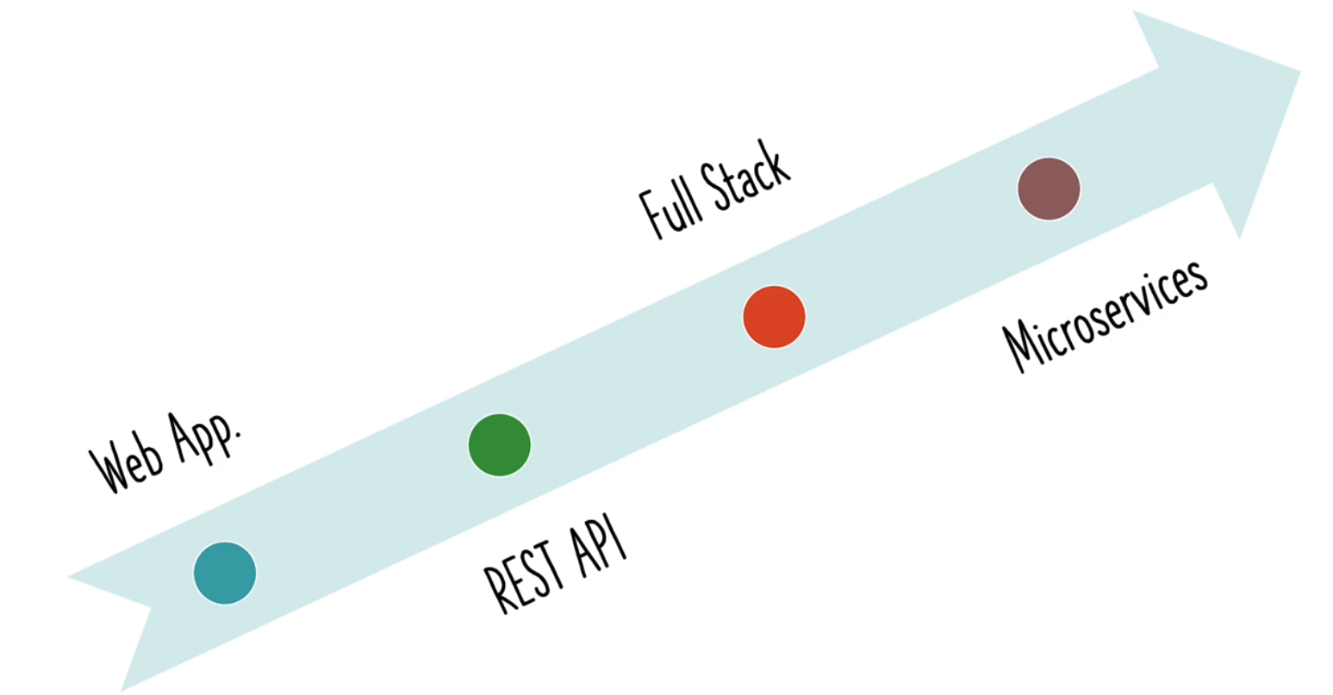

We use number of **frameworks** to build our applications.

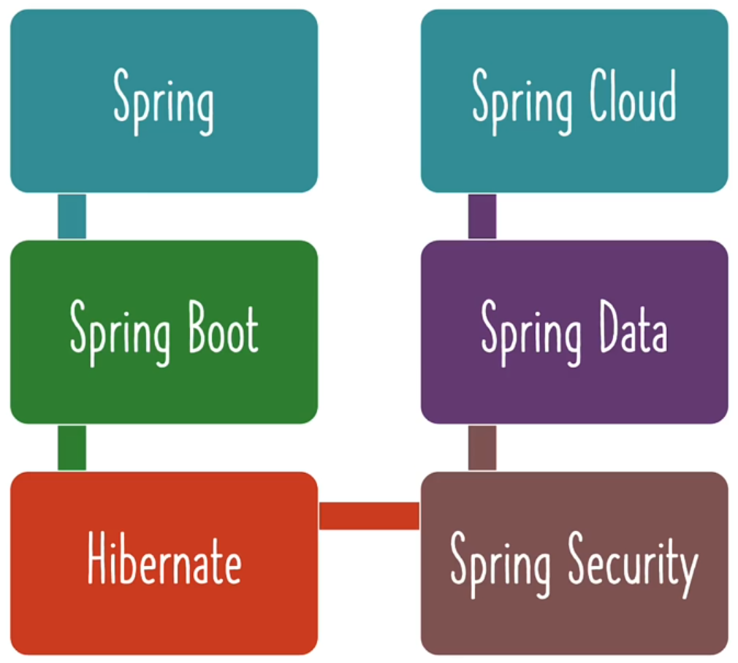

What are the **two most important frameworks** we need to learn to get started with building great applications?

**1. Spring Framework:**

Spring framework provides the most important features needed to build easily maintainable applications.

**Example**:

* **Dependency Injection**
* **Auto wiring**

**2. Spring Boot:**

Spring boot makes using **spring framework easy**.

**Example**:

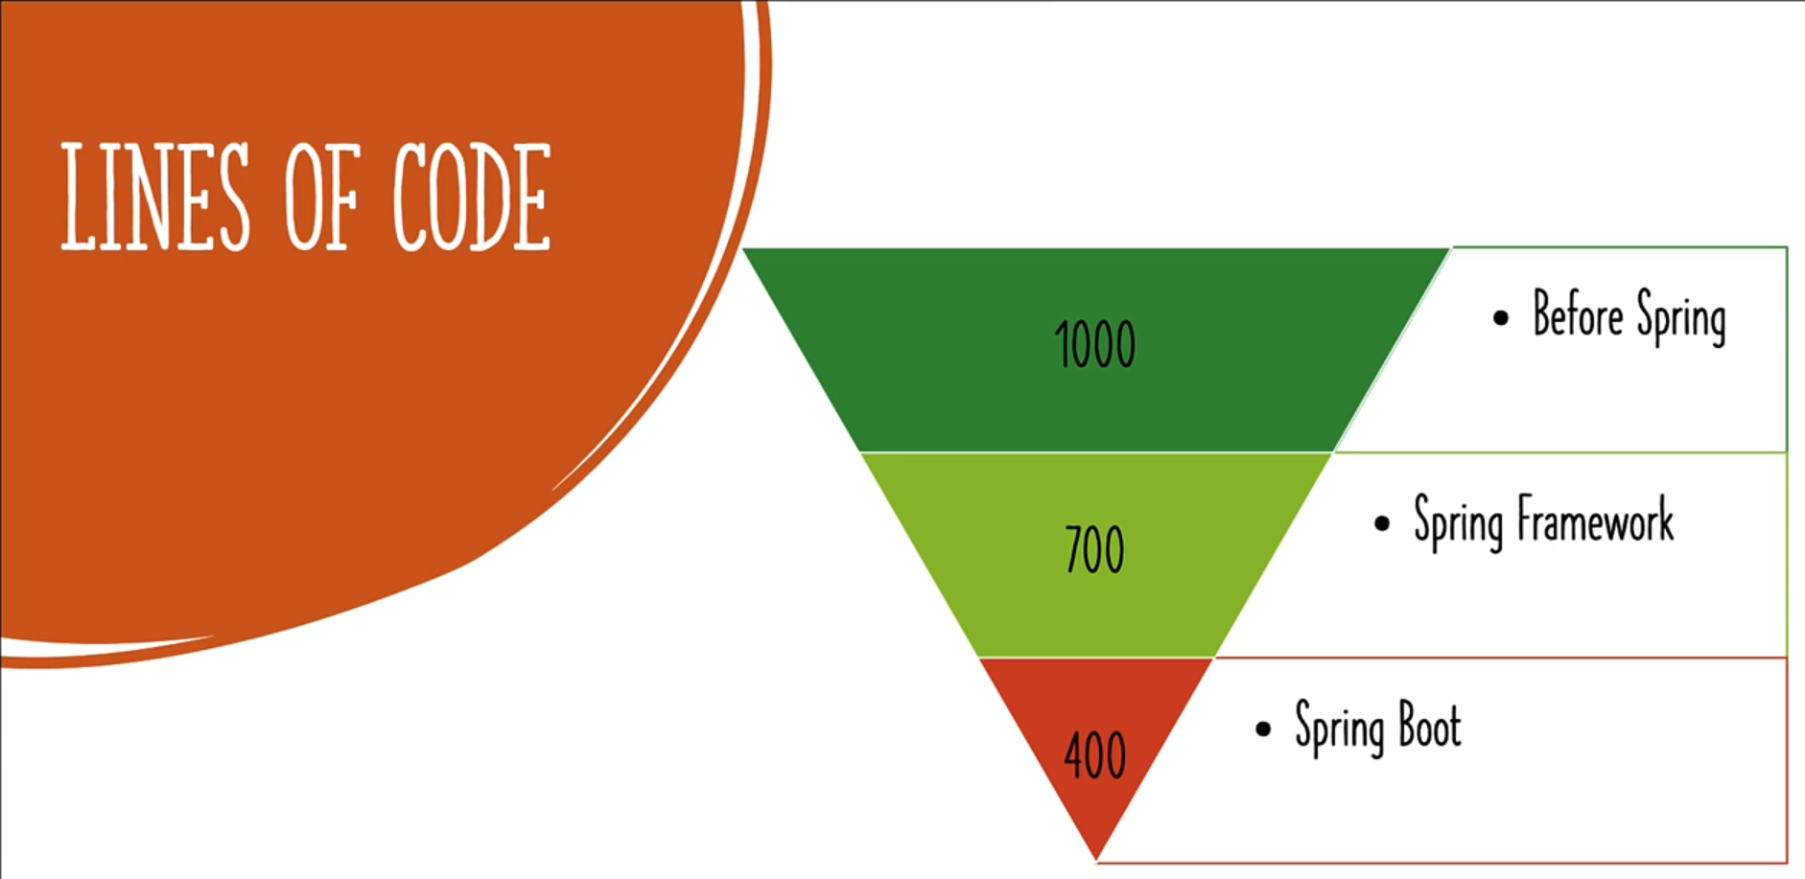

So, Spring and Spring boot **improve our productivity** a lot. We can be able to **do lot more with lot less code**.

A lot more **terminologies** are there in spring framework.

